PHASE 1 INTERIM FINDINGS · COMPONENTS 2 & 3 OF THE SCOPE OF WORK
Gates Masculinity Project
Content analysis & audience reception findings — Kenya × Nigeria
This deliverable maps onto Component 2 (Content analysis) and Component 3 (Audience reception analysis) of the Scope of Work. Findings on core topics, themes, narratives, sentiments, rhetorical strategies, and audience perceived impact are designed to feed Component 4 — Playbook development — by surfacing the entry points and counternarrative levers visible in the data.
All 1604 rows coded by gpt-4o-mini with OpenAI Structured Outputs · sentiment 4-valued (positive · negative · neutral · unclear) · 829 audience comments and 775 content snippets across 11 selected creators (5 Kenya, 6 Nigeria).
412  Kenya audience comments | 394  Kenya content snippets | 417  Nigeria audience comments | 381  Nigeria content snippets
43%  Kenya regressive content | 35%  Kenya progressive content | 43%  Nigeria regressive content | 31%  Nigeria progressive content

HOW THIS REPORT MAPS TO THE SCOPE OF WORK
Scope output → Section in this report
Core topics → Section 3 · Masculinity narratives → Section 4 · Themes / framing → Section 5
Problems & solutions diagnosed → Section 6 · Sentiments → Section 7 · Rhetorical strategies → Section 8
Argument types (content) → Section 9 · Misogyny / sexism → Section 10 · Regressive ↔ progressive orientation → Section 11
Content cluster / entry-point map → Sections 12–13 · Audience sentiment / emotion / perceived impact → Sections 14–19
Linked content–audience analysis → Sections 20–21 · Playbook implications (Component 4 bridge) → Sections 22–23

EXECUTIVE SUMMARY — WHAT THE DATA SAYS
1. Two distinct masculinity ecosystems. Kenya's dominant narrative is “men are disadvantaged victims” (92 / 394 = 23%, top in 4 of 5 creators); Nigeria's is “men should provide and succeed” (79 / 381 = 21%). The grievance register vs. the provider register are different doors into the same ecosystem.
2. Regressive content concentrates in identifiable creators. Kibe + Amerix in Kenya account for 157 of 171 regressive snippets (92% of all Kenyan regressive content). Agba JD + Shola + Wizarab account for the bulk of Nigerian regressive content.
3. Solutions diagnosis is thin. 44% of Kenyan and 59% of Nigerian content snippets propose “no clear solution” — creators identify problems but rarely prescribe constructive paths. The largest non-empty solutions are emotional_growth_healing (KE: 102) and family_responsibility (NG: 54) — both already counternarrative-friendly.
4. Audience perceived impact diverges sharply. Kenyan audiences report validation (155) > pushback (100) — acknowledging or extending the creator. Nigerian audiences flip this: pushback (150) > validation (113) . Nigeria's threads are organised counter-publics, not echo chambers.
5. Healing / testimony register is the strongest counternarrative lever. Rixpoet's audience codes 88% supports + 85% extends/intensifies around trauma-healing content; Banky Wellington gets the same pattern in Nigeria. The healing register is the only register in our sample that produces both learning_reflection and personal_disclosure at scale.
6. Audience opens frames creators do not foreground. In Nigeria, violence_safety appears in 39 audience comments but only 3 content snippets — Deyemi Okanlawon's audience pulls a GBV / safety frame his tweets do not raise. This is a counternarrative seed.
7. Hostile sexism is concentrated; benevolent sexism is the larger pipeline. Hostile/dehumanising sexism appears in ~20% of regressive content; benevolent / traditional sexism (“submit”, “headship”, “real man provides”) is the ambient register through which gender hierarchy is reproduced as common-sense.

PART A · SCOPE AND APPROACH
1. What this report covers
The Scope of Work specifies four components: (1) Landscape analysis, (2) Content analysis, (3) Audience reception analysis, (4) Playbook development. This deliverable corresponds to Components 2 and 3, with explicit hooks into Component 4 in Sections 22–23. Per the Scope, content analysis surfaces “core topics, themes, narratives, sentiments, and rhetorical strategies” and how they “cluster together… surfacing how different entry points might function”. Audience reception analysis surfaces “sentiment, emotions, and perceived impact of the content, as reported by engaged audiences”. Each scope-named output appears as a numbered section below.
2. Sample composition
Eleven masculinity-associated creators across Kenya and Nigeria, drawn from the manosphere-adjacent ecosystem identified in the landscape analysis. Sample fits the Scope's “3-5 per country” guideline and the “up to 1,600 comments total”.
Creator | Country | Snippets (n) | Comments (n) | Regressive % | Progressive %
Onyango Otieno (Rixpoet) | Kenya | 100 | 92 | 9% | 49%
Eric Amunga (Amerix) | Kenya | 97 | 140 | 86% | 12%
Andrew Kibe | Kenya | 91 | 70 | 81% | 13%
Eddy Kimani | Kenya | 65 | 110 | 2% | 71%
Philip Karanja | Kenya | 41 | 0 | 10% | 46%
Ebuka Obi-Uchendu | Nigeria | 83 | 0 | 16% | 34%
Agba John Doe | Nigeria | 77 | 161 | 78% | 10%
Banky Wellington | Nigeria | 76 | 110 | 8% | 64%
Shola | Nigeria | 72 | 66 | 78% | 14%
Wizarab | Nigeria | 49 | 0 | 59% | 14%
Deyemi Okanlawon | Nigeria | 24 | 80 | 4% | 62%

PART B · CONTENT FINDINGS (SCOPE COMPONENT 2)
3. Core topics — what creators talk about
Scope: “core topics”. Kenya's content centres on mental_health (~30%); Nigeria's on dating_relationships (~38%). The two ecosystems pivot around different doors.
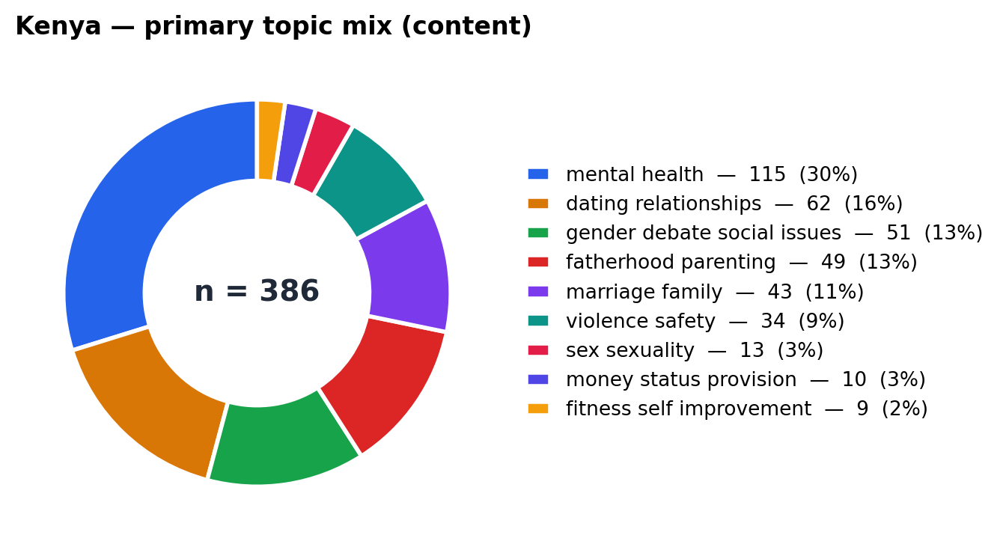
Kenya — mental_health 31%, dating_relationships 16%, gender_debate 14%, fatherhood 13%.
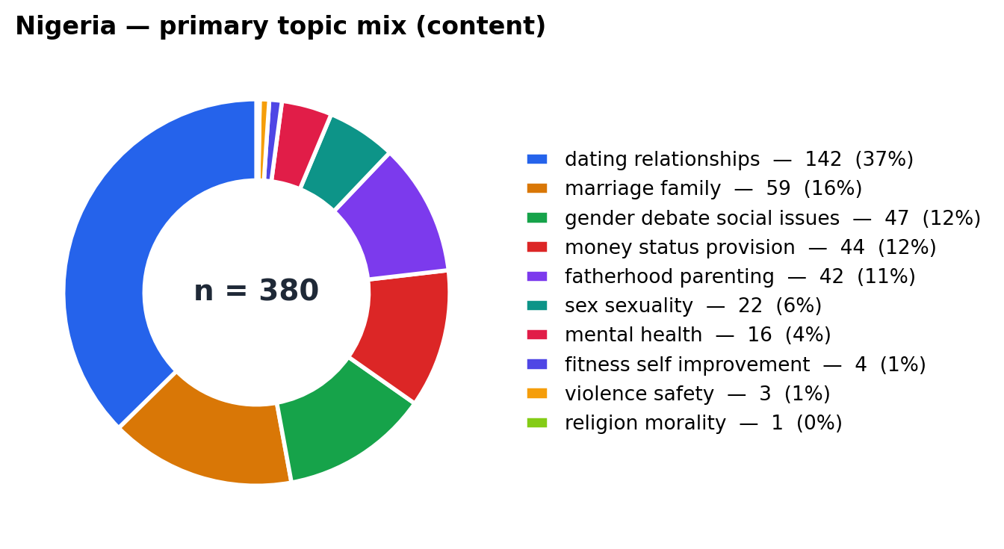
Nigeria — dating_relationships 38%, marriage_family 16%, gender_debate 13%, money / status 12%.
4. Masculinity narratives — how men “should” be portrayed
Scope: “narratives”. Each snippet is coded for the underlying masculinity model it pushes (or “none” if the snippet is descriptive rather than prescriptive).
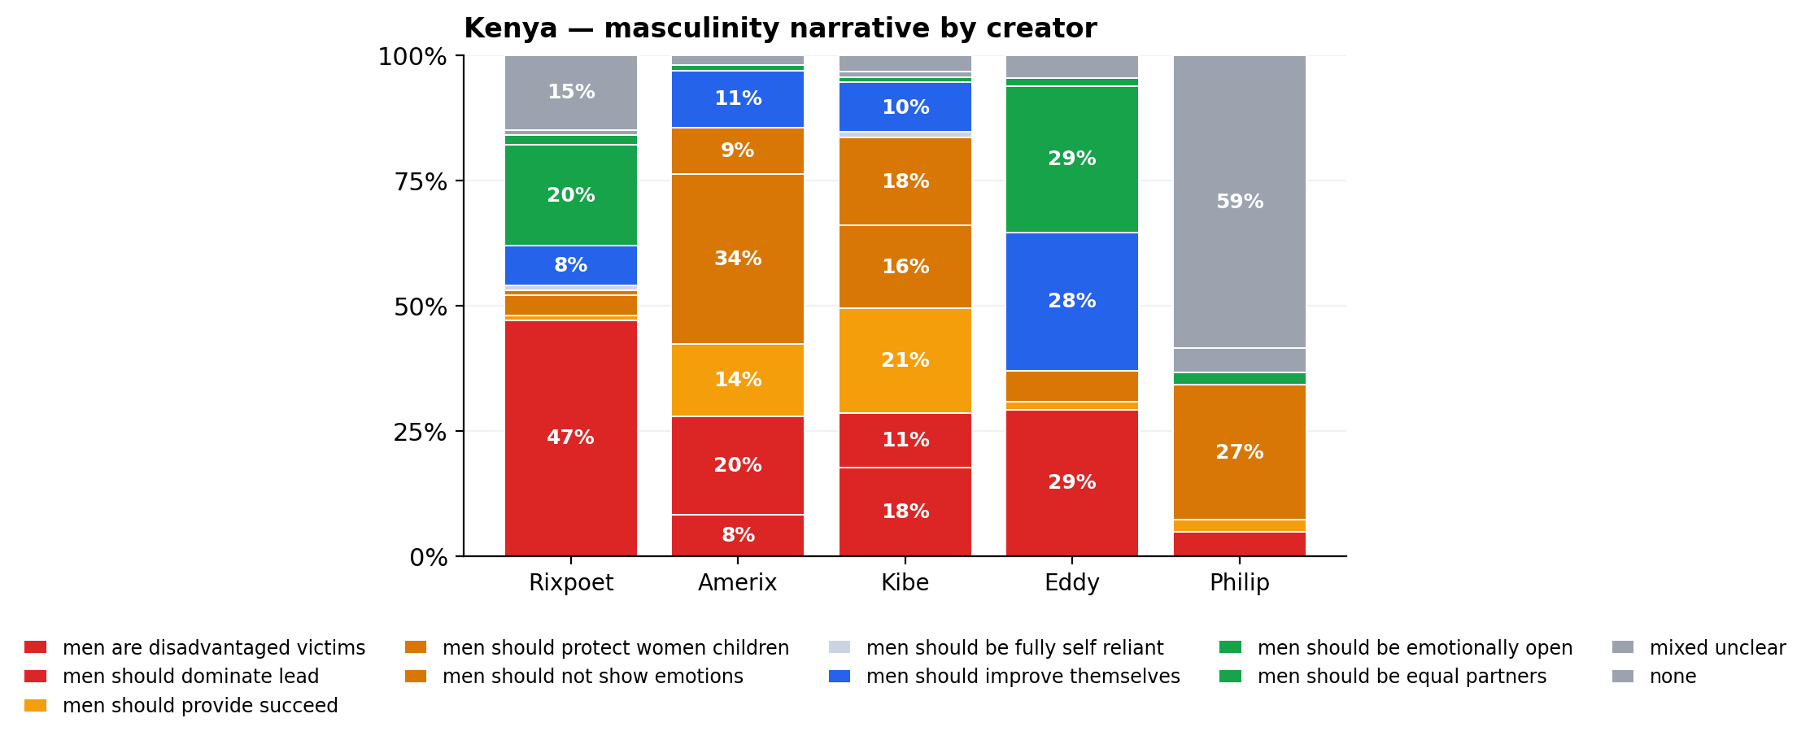 | 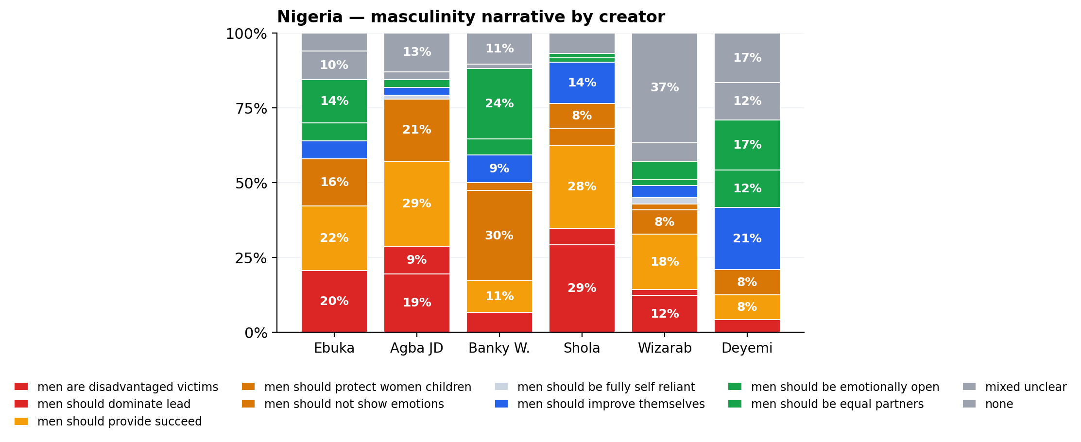
Kenya — “men are disadvantaged victims” dominates Kibe and Amerix; “emotionally open” dominates Eddy and Rixpoet. | Nigeria — “provide and succeed” dominates Agba JD and Shola; “equal partners” dominates Banky W. and Ebuka.

CROSS-COUNTRY NARRATIVE CONTRAST
Top Kenyan narrative: men_are_disadvantaged_victims (92)
Top Nigerian narrative: men_should_provide_succeed (79)
Vulnerability counter-narrative is alive in Kenya (“emotionally open” 41 snippets) but thin in Nigeria (14). Equality counter-narrative is alive in Nigeria (“equal partners” 40 snippets) but nearly absent in Kenya (4).

5. Themes and framing — how topics are framed
Scope: “themes”. Each snippet/comment is coded for its dominant frame (the package of meaning around the topic). Top frames per country, content vs audience.
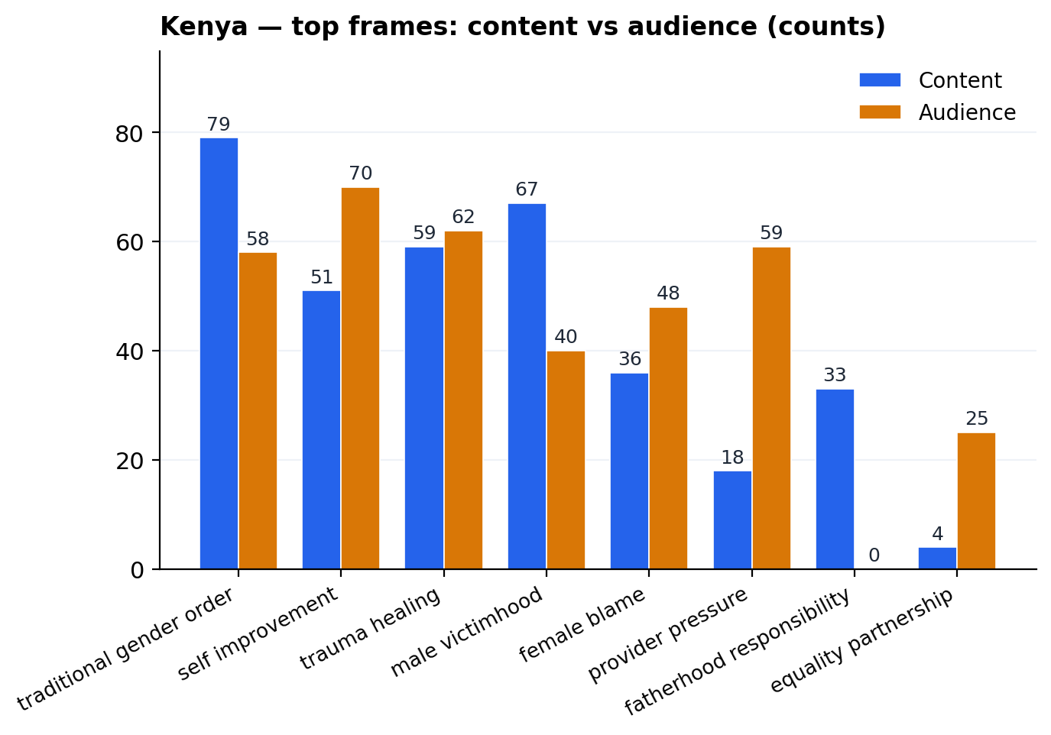
Kenya — content & audience overlap on traditional_gender_order (79/58) and trauma_healing (59/62); audience opens self_improvement (51→70) and provider_pressure (18→59).
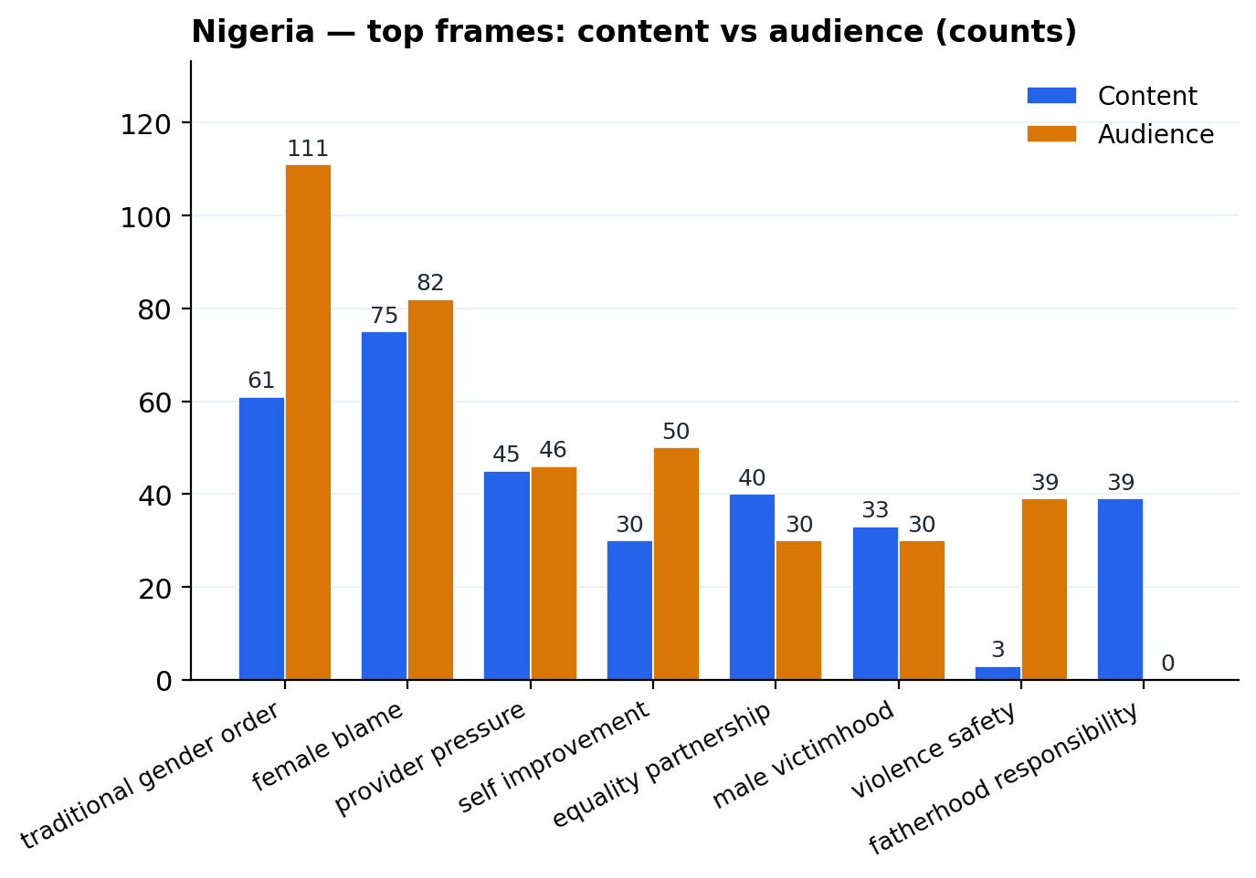
Nigeria — audiences inflate traditional_gender_order (61→111) and female_blame (75→82); violence_safety opens spontaneously (3→39 audience comments).
6. Problems and solutions diagnosed
Beyond “what is the topic”, we code what each snippet says is wrong (the problem) and what it prescribes (the solution). Surfacing these tells us where existing creators already build counter-narrative bridges — and where they leave gaps.
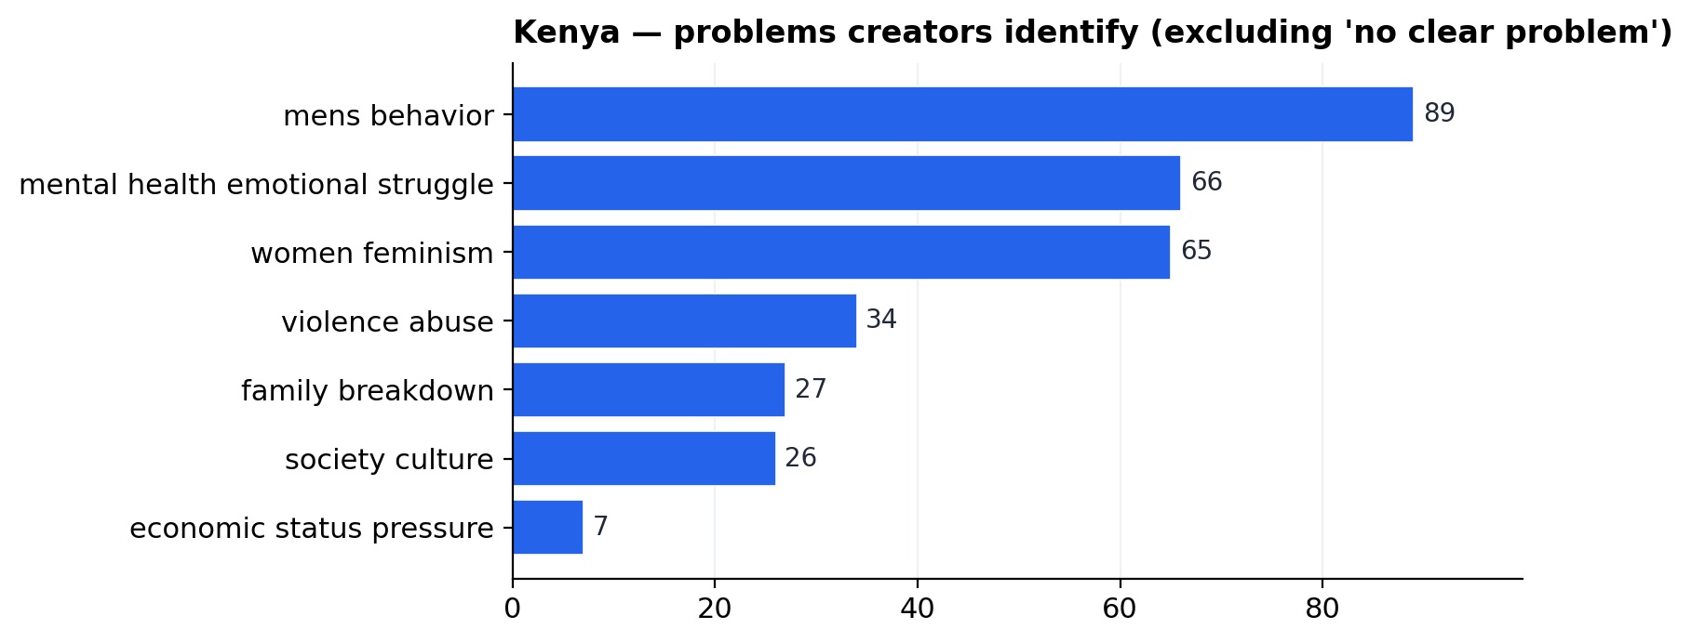 | 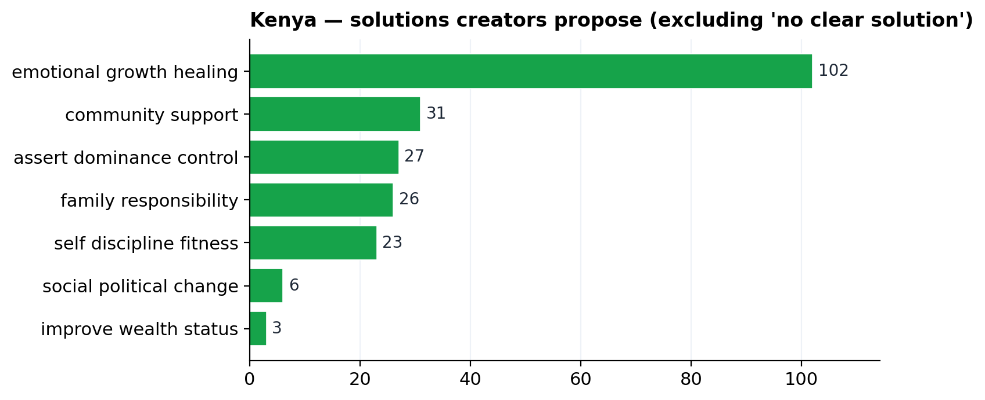
Kenya problems — mens_behavior leads, but mental_health is uncommonly high (66). | Kenya solutions — emotional_growth_healing dominates (102) — testimony register.

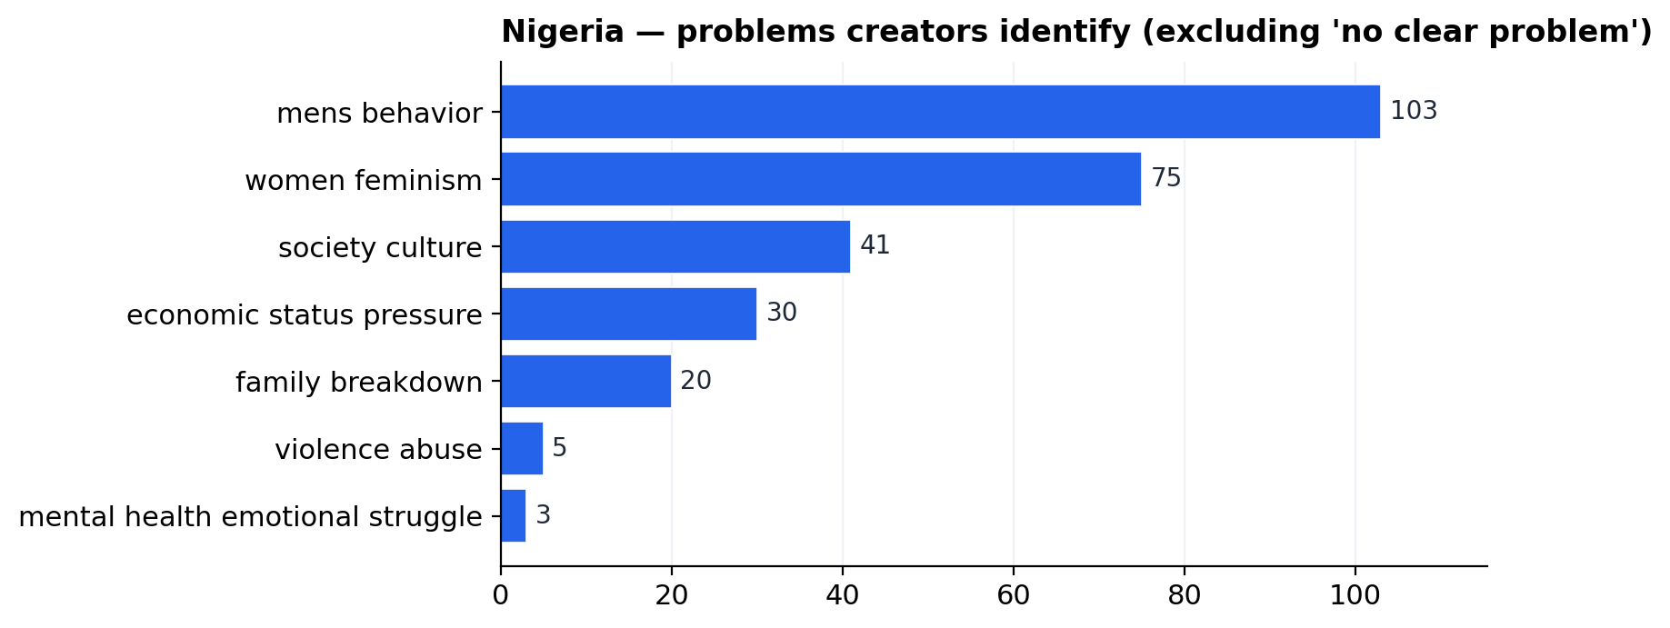 | 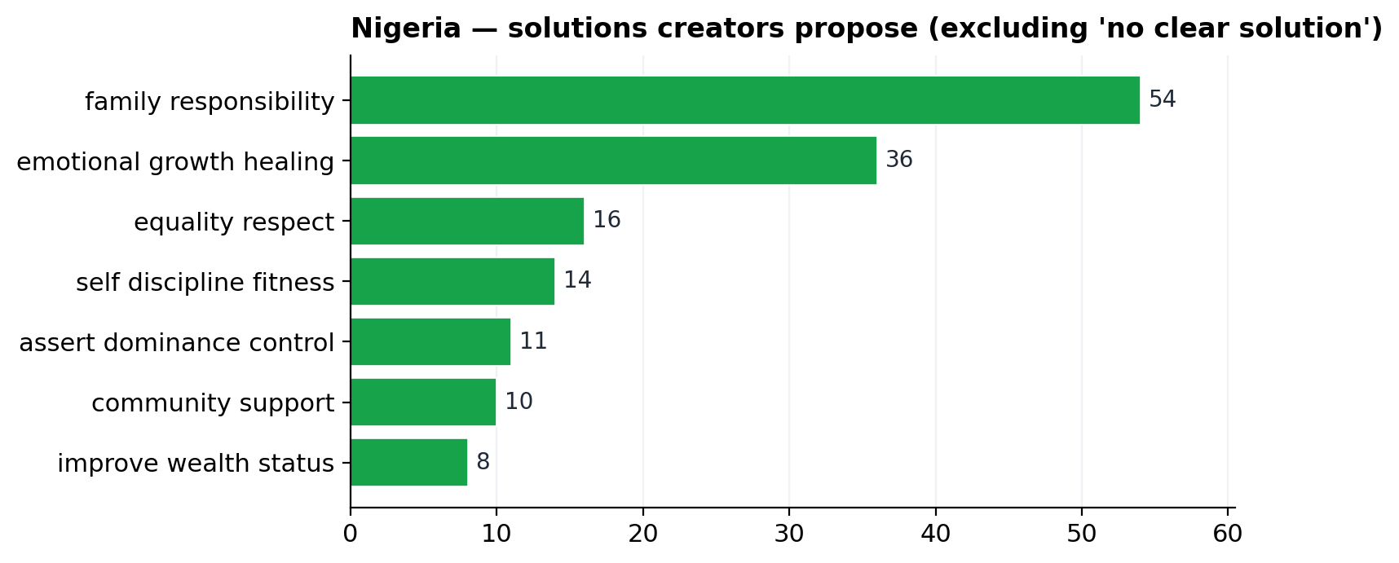
Nigeria problems — mens_behavior + women_feminism dominate; mental_health is nearly absent (3). | Nigeria solutions — family_responsibility leads (54), emotional_growth_healing distant second (36).

Diagnosis-only register. 172 of 394 Kenyan and 226 of 381 Nigerian content snippets propose no clear solution— creators identify problems but do not consistently prescribe pathways. The playbook can occupy the prescribed-pathway gap directly.

7. Three-axis sentiment — toward men, women, and traditional norms
Scope: “sentiments”. A generic sentiment score collapses too much, so each content snippet is coded separately for its sentiment toward men, toward women, and toward traditional gender norms. Cells are row counts.
Kenya · n = 394
Target | positive | negative | neutral | unclear
men | 181 | 98 | 115 | 0
women | 27 | 127 | 234 | 6
norms | 65 | 153 | 174 | 2
Nigeria · n = 381
Target | positive | negative | neutral | unclear
men | 128 | 67 | 186 | 0
women | 48 | 137 | 195 | 1
norms | 51 | 183 | 147 | 0

Sentiment toward women is mostly neutral in both corpora — content rarely stakes out a positive/negative position on women specifically; it argues about hierarchy, provision, or healing. Where it does stake a position, it tilts negative.
Sentiment toward traditional norms is more polarised — Nigerian content is notably more critical of those norms (48% negative) than Kenyan content (39%).
8. Rhetorical strategies — how creators package the message
Scope: “rhetorical strategies”. Each snippet is coded for its dominant rhetorical mode: commentary/opinion, advice/instruction, debate/argument, personal_story, testimony, motivational_speech, religious/moral teaching, humor/satire, warning/threat, news/facts.
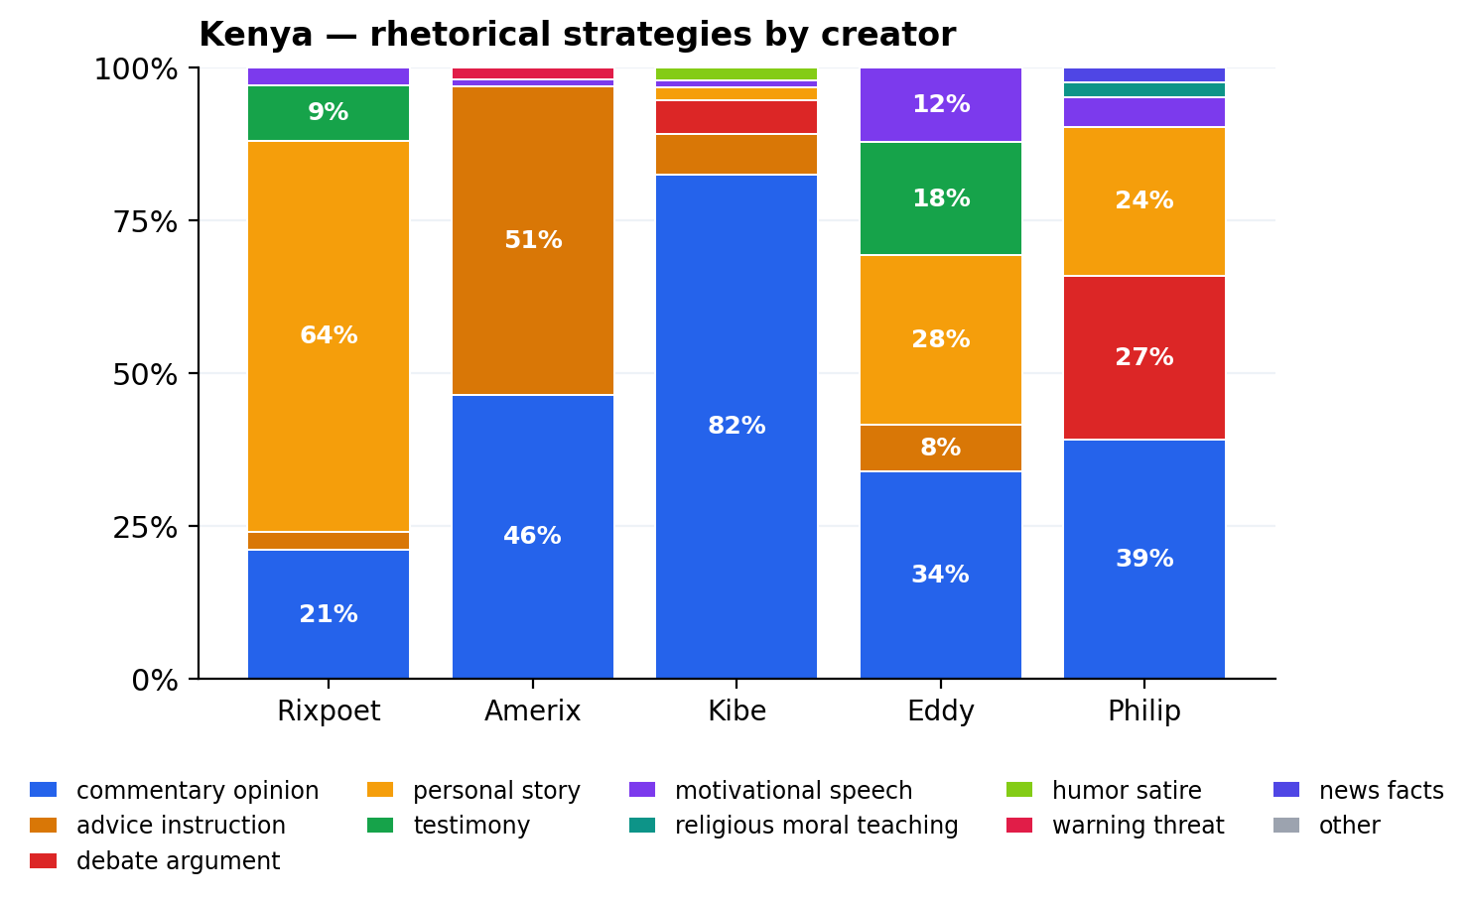 | 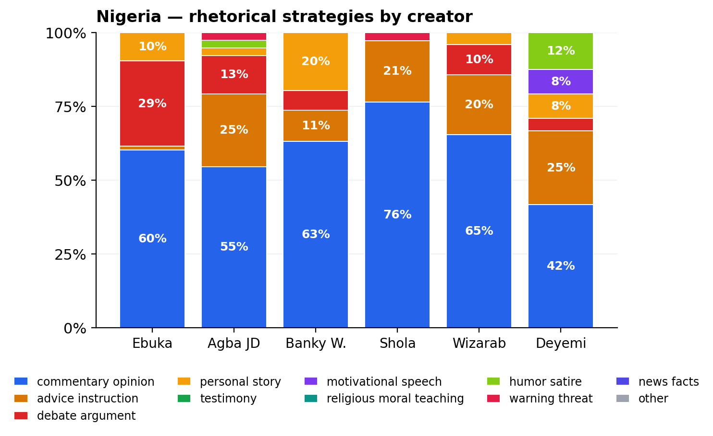
Kenya — testimony + personal_story spike under Rixpoet & Eddy; advice/instruction concentrates in Amerix. | Nigeria — debate_argument is the highest in Nigeria (Deyemi); commentary_opinion dominates the rest.

The healing/testimony register (21 testimony + 94 personal_story Kenyan snippets) is the strongest single rhetorical signature of progressive content. It correlates with the highest rates of audience personal_disclosure and learning_reflection (see Section 16).

9. Argument types — how creators justify claims
Generalisation dominates both countries. Personal_experience is the second-largest content argument type in Kenya (driven by Rixpoet) but trails advice_instruction in Nigeria.
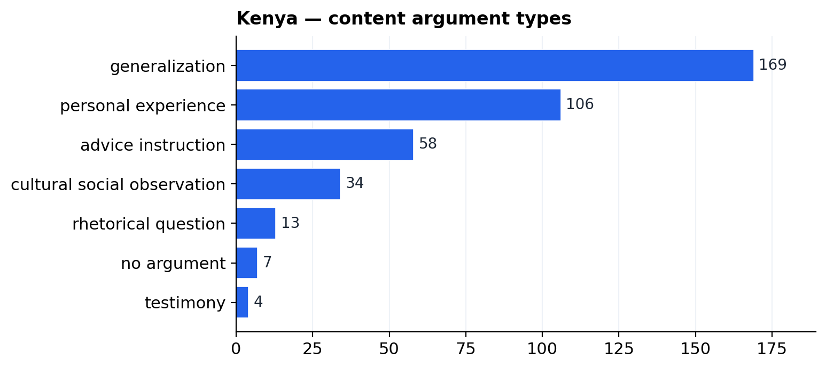 | 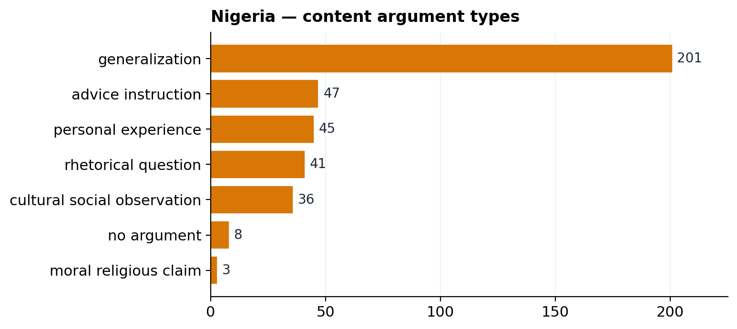
Kenya content arguments — generalization (169) leads; personal_experience (106) is unusually high. | Nigeria content arguments — generalization (201) dominates; advice_instruction (47) replaces personal_experience.

10. Misogyny / sexism distribution (content side)
Hostile and dehumanising sexism is rare in absolute volume but tightly concentrated. Benevolent / traditional sexism (“submit”, “headship”, “real man provides”) is the larger ambient vehicle of gender hierarchy.
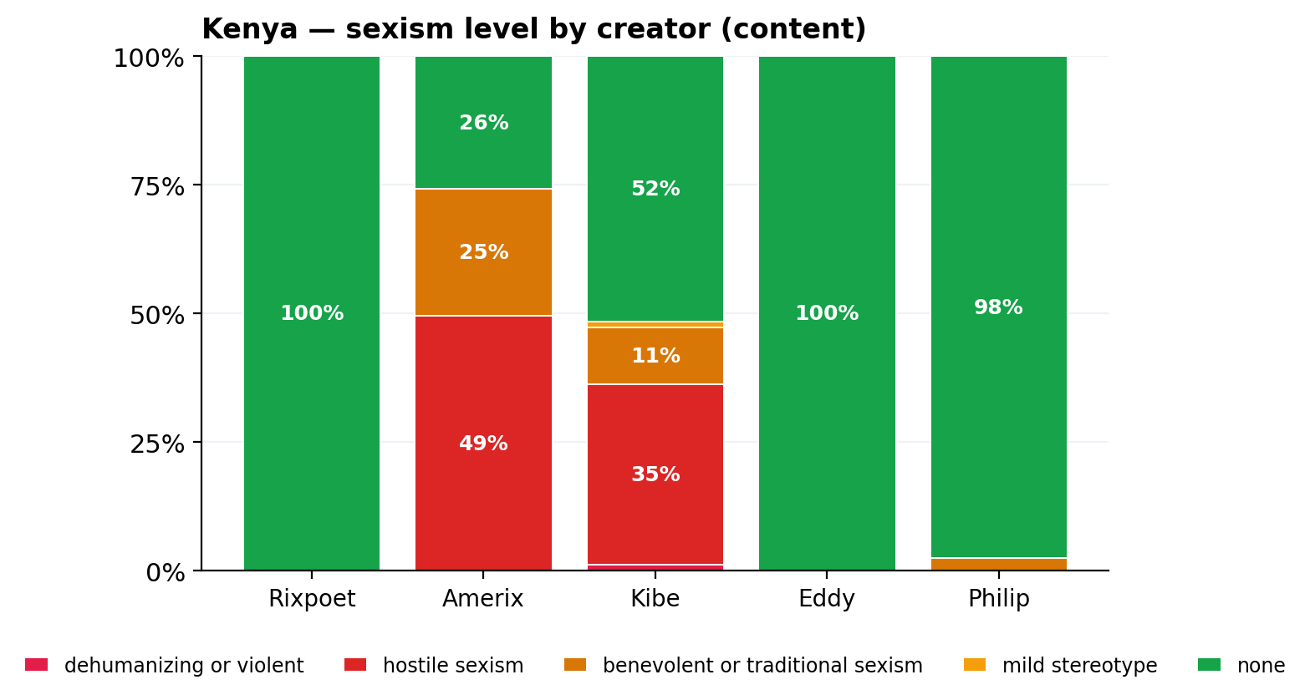 | 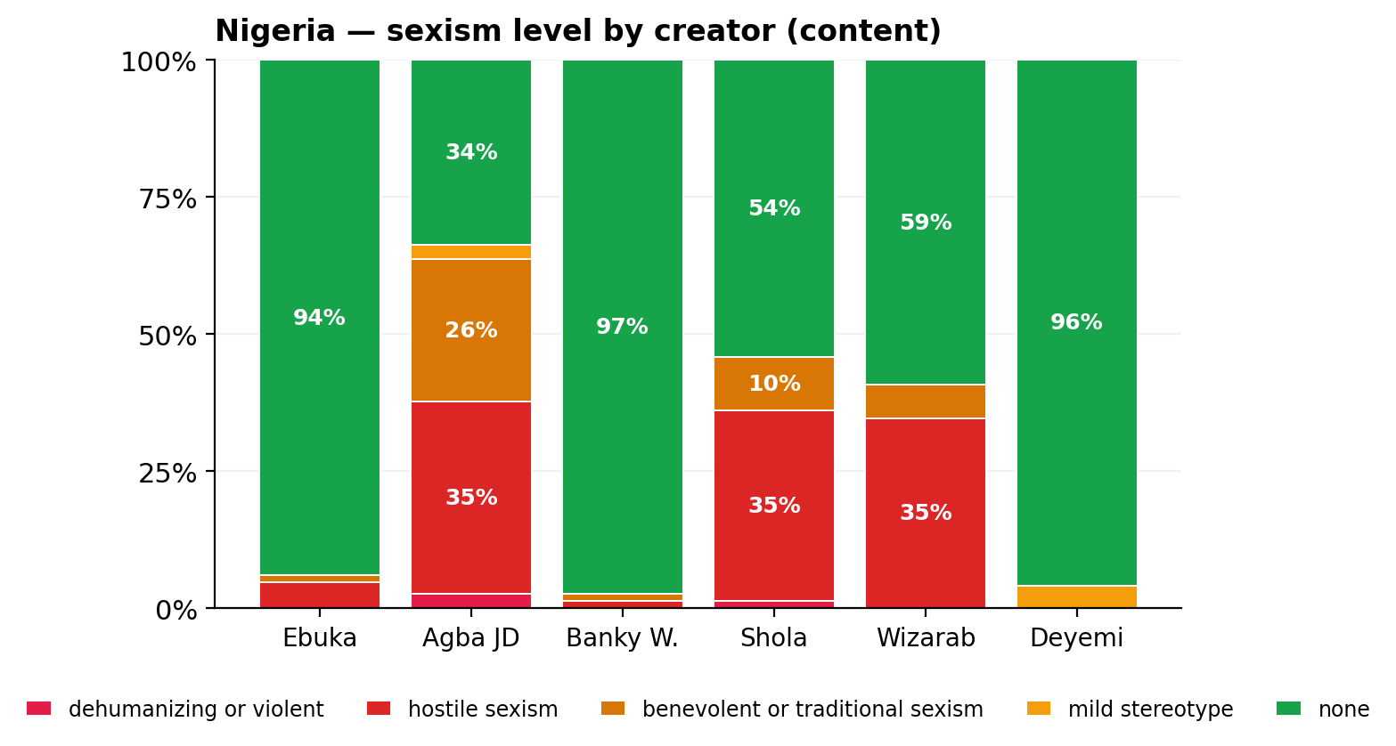
Kenya — Amerix is the most hostile-sexism-heavy creator; Rixpoet & Eddy code 0%. | Nigeria — Agba JD, Shola, Wizarab carry most sexism load; Ebuka, Deyemi, Banky almost free.

11. Regressive ↔ progressive orientation by creator
Each snippet is coded along a regressive ↔ progressive axis. Regressive = reinforces hierarchy, domination, female submission, misogyny, rigid provider roles, anti-feminism, male grievance. Progressive = promotes equality, accountability, emotional openness, anti-violence, healing, partnership.
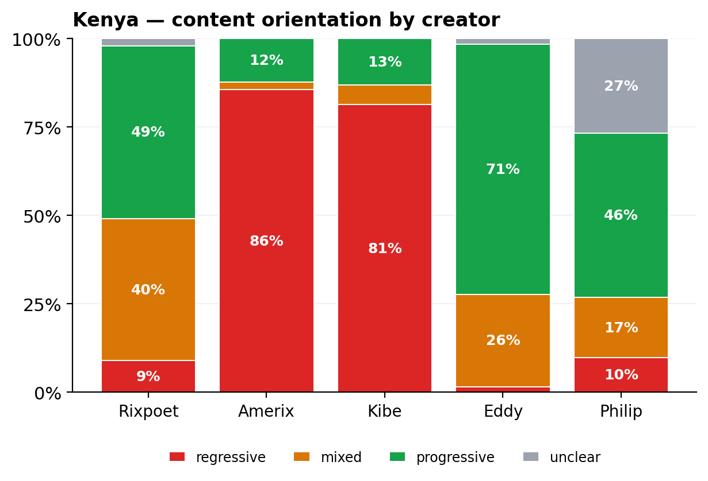 | 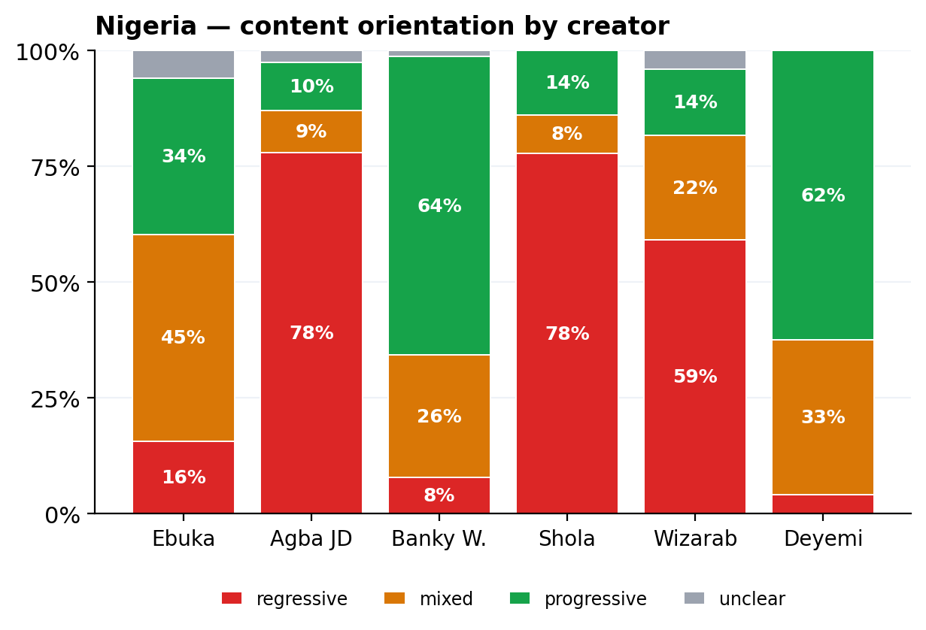
Kenya — Kibe & Amerix sit ~85% regressive; Eddy & Rixpoet are progressive-leaning. | Nigeria — Agba JD, Shola, Wizarab regressive-dominant; Banky W. & Deyemi mostly progressive.

PART C · CONTENT CLUSTERS AND ENTRY POINTS
12. Per-creator profile — the entry-point map
Each row is one creator's dominant cluster across the scope-named outputs. Read this as the fingerprint of the door the creator is the most-likely to be entering through.
Kenya
Creator | Top topic | Top narrative | Top frame | Top rhetoric | Reg % | Prog % | Sex % | Sup % | Opp %
Rixpoet | mental health | men are disadvantaged victims | trauma healing | personal story | 9% | 49% | 0% | 88% | 10%
Amerix | dating relationships | men should protect women children | traditional gender order | advice instruction | 86% | 12% | 74% | 41% | 55%
Kibe | marriage family | men should provide succeed | traditional gender order | commentary opinion | 81% | 13% | 47% | 44% | 46%
Eddy | mental health | men are disadvantaged victims | self improvement | commentary opinion | 2% | 71% | 0% | 64% | 32%
Philip | violence safety | men should protect women children | fatherhood responsibility | commentary opinion | 10% | 46% | 2% | — | —
Nigeria
Creator | Top topic | Top narrative | Top frame | Top rhetoric | Reg % | Prog % | Sex % | Sup % | Opp %
Ebuka | dating relationships | men should provide succeed | provider pressure | commentary opinion | 16% | 34% | 6% | — | —
Agba JD | marriage family | men should provide succeed | traditional gender order | commentary opinion | 78% | 10% | 64% | 53% | 41%
Banky W. | fatherhood parenting | men should protect women children | fatherhood responsibility | commentary opinion | 8% | 64% | 3% | 69% | 17%
Shola | dating relationships | men are disadvantaged victims | female blame | commentary opinion | 78% | 14% | 46% | 52% | 48%
Wizarab | dating relationships | men should provide succeed | female blame | commentary opinion | 59% | 14% | 41% | — | —
Deyemi | dating relationships | men should improve themselves | equality partnership | commentary opinion | 4% | 62% | 0% | 11% | 85%
Sex % = share of content snippets coded as hostile, dehumanising, or benevolent/traditional sexism (any positive sexism level). Sup / Opp % = supports / opposes share of audience comments under that creator.
13. Four entry-point archetypes — how audiences land here
Reading down the profile table, four archetypes emerge in this sample. Each is a coherent topic + narrative + rhetorical + sexism cluster. Audiences enter the masculinity ecosystem through one of these doors.
ARCHETYPE 1 — GRIEVANCE + DOMINANCE
Creators: Andrew Kibe, Eric Amunga (Amerix), Wizarab. Narrative: “men are disadvantaged victims” / “men should dominate, lead”.
Topic mix: gender_debate, dating_relationships. Frame: traditional_gender_order, male_victimhood, female_blame. Rhetoric: advice_instruction + commentary_opinion. Hostile-sexism rate: 35–55%.
Engagement signature: high opposes share (Amerix 56% opposes), audience uptake is split between intensifies and challenges. This is the manosphere-aligned door.

ARCHETYPE 2 — PROVIDER + TRADITIONAL ORDER
Creators: Shola, Agba John Doe. Narrative: “men should provide and succeed” / “men should protect women & children”.
Topic mix: dating_relationships, money_status_provision, marriage_family. Frame: traditional_gender_order, provider_pressure, female_blame. Rhetoric: commentary_opinion. Hostile-sexism rate: ~30%.
Engagement signature: high audience supports, intensifies original message. This is the soft-regressive entry-point — ‘common-sense’ framing of hierarchy through wealth and bridewealth.

ARCHETYPE 3 — HEALING + EMOTIONAL GROWTH
Creators: Onyango Otieno (Rixpoet), Eddy Kimani, Banky Wellington. Narrative: “men should be emotionally open” / “men should improve themselves”.
Topic mix: mental_health, fatherhood_parenting, gender_debate. Frame: trauma_healing, self_improvement, equality_partnership. Rhetoric: testimony + personal_story + motivational_speech. Hostile-sexism rate: ~0%.
Engagement signature: high supports + extends_original_message; audience reports personal_disclosure and learning_reflection at unique rates. This is the strongest existing counternarrative platform in the data.

ARCHETYPE 4 — PARTNERSHIP + FATHERHOOD
Creators: Banky Wellington, Deyemi Okanlawon, Ebuka Obi-Uchendu, Philip Karanja. Narrative: “men should be equal partners” / “men should protect women & children”.
Topic mix: marriage_family, fatherhood_parenting. Frame: equality_partnership, fatherhood_responsibility. Rhetoric: commentary_opinion + advice_instruction. Hostile-sexism rate: ~3%.
Engagement signature: Banky Wellington gets high supports + extends; Deyemi Okanlawon gets organised opposition (68 vs 9). Partnership/fatherhood content can be rejected as moralism unless paired with the healing register (Archetype 3).

PART D · AUDIENCE RECEPTION FINDINGS (SCOPE COMPONENT 3)
14. Audience stance toward post
Scope: audience reception. Stance is coded toward the original post, not toward gender in general.
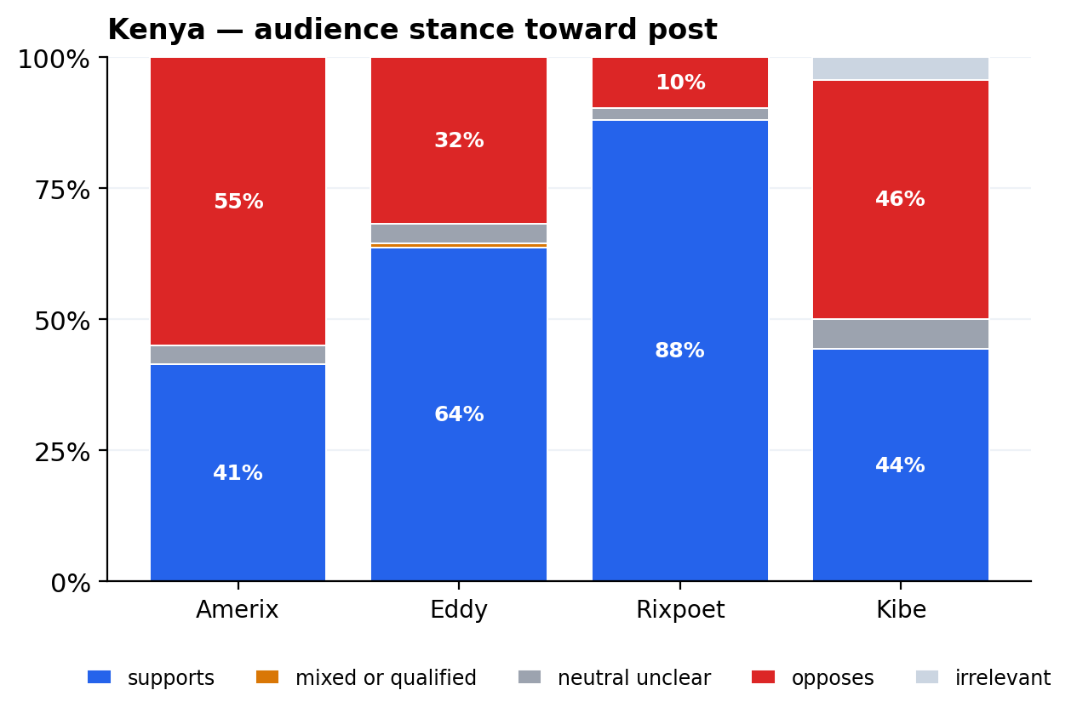 | 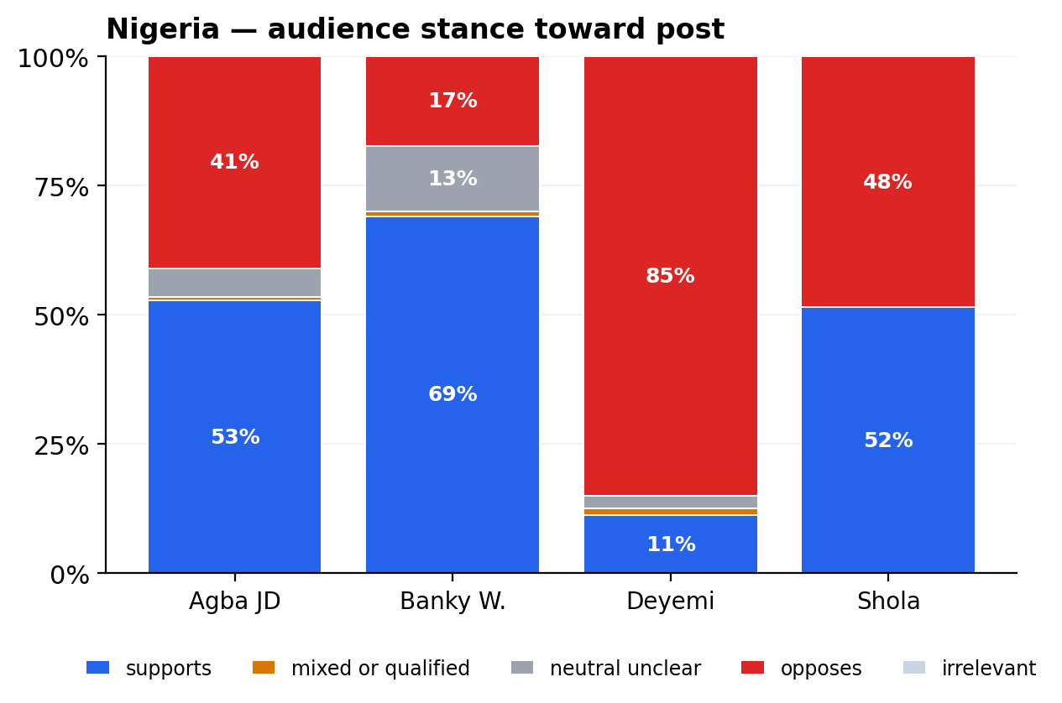
Kenya — Rixpoet's audience is ~89% supportive; Amerix gets the most opposition. | Nigeria — Deyemi's audience is overwhelmingly oppositional (68 vs 9 in absolute terms).

15. Audience uptake mode — beyond agree / disagree
Each comment is coded for how it relates to the post: intensifies (more extreme), extends (agrees + adds reasoning), softens, or challenges. This separates passive agreement from active amplification.
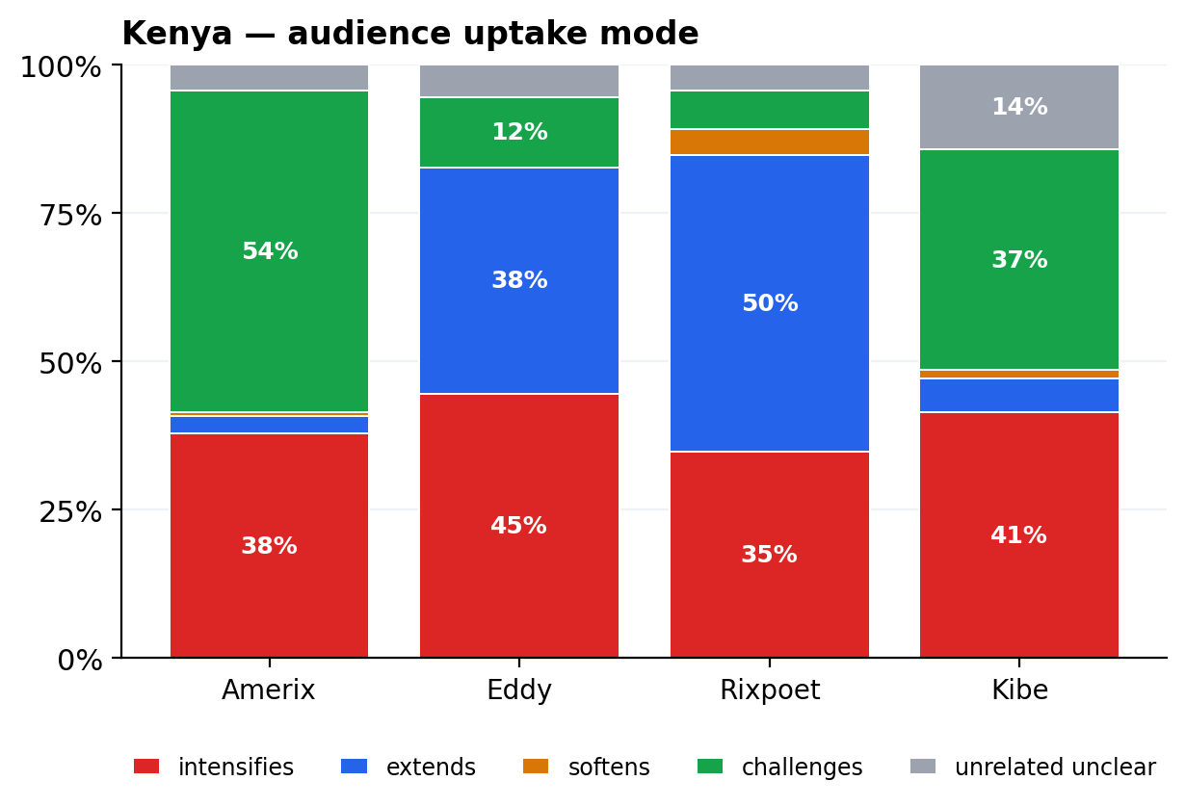 | 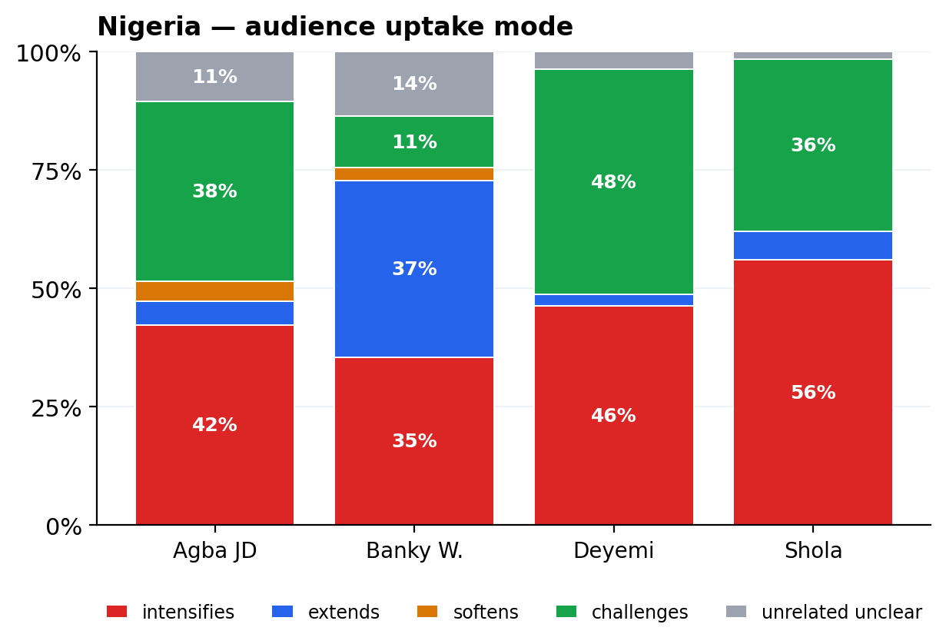
Kenya — Rixpoet's audience extends; Amerix's intensifies and challenges. | Nigeria — Banky Wellington's audience extends; Agba JD's intensifies and challenges in equal measure.

16. Perceived impact — what audiences say the content does to them
Scope: “perceived impact of the content as reported by engaged audiences”. Each comment is coded for what kind of impact it reports: validation, learning_reflection, personal_disclosure, advice_to_others, resistance_pushback, emotional_support, entertainment_humor, or no_clear_impact.
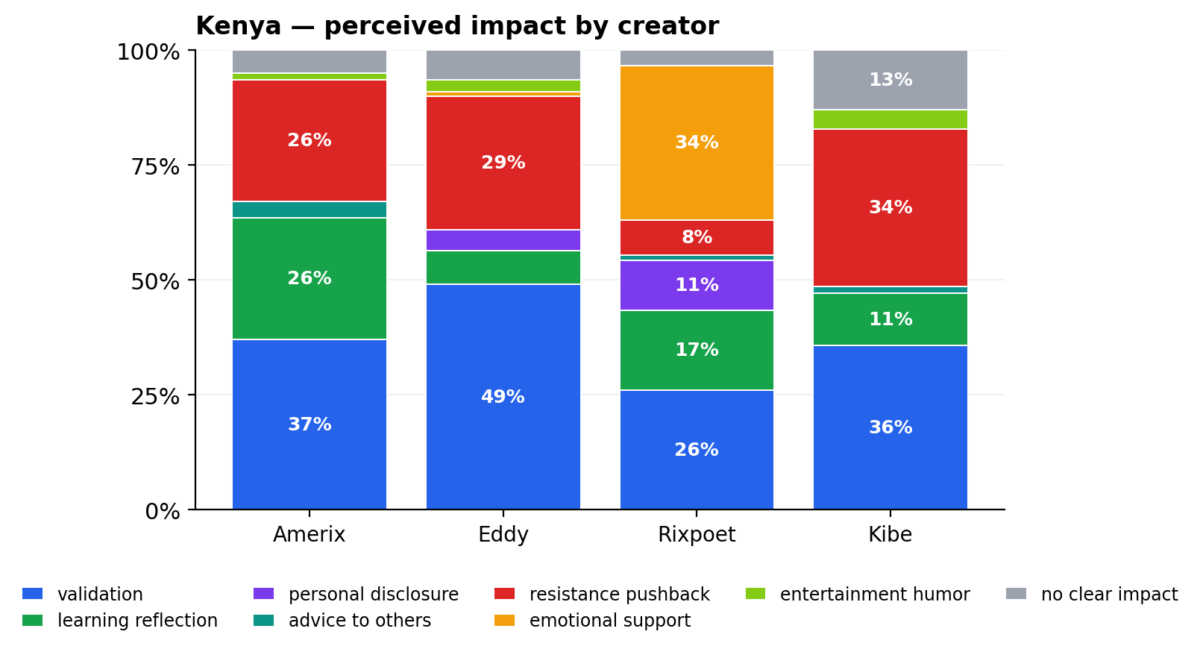 | 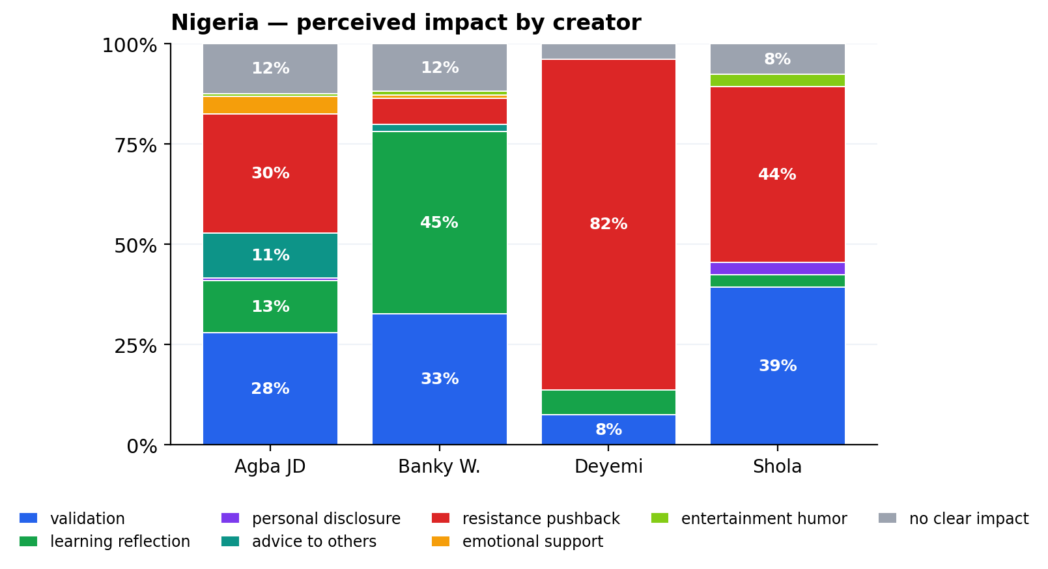
Kenya — Rixpoet drives personal_disclosure + learning_reflection; Amerix drives resistance_pushback. | Nigeria — Banky Wellington drives learning_reflection + emotional_support; Deyemi drives resistance_pushback.

KEY CONTRAST
Kenya: validation (155) > resistance_pushback (100) > learning_reflection (69). Audiences are mostly here to acknowledge or extend.
Nigeria: resistance_pushback (150) > validation (113) > learning_reflection (78). The Nigerian comment threads are organised counter-publics, not echo chambers — important for playbook framing.
Personal disclosure is a Kenya-specific signature (15 vs 3 in Nigeria), almost entirely under the healing register. Where it appears, it correlates with learning_reflection and emotional_support— the ‘healthy reception’ cluster.

17. Emotion landscape — audience comments
Anger and contempt cluster on regressive creators. Hope, admiration and concern cluster on progressive creators. Sadness is rare but meaningful — almost exclusively under healing-content (Rixpoet, Banky Wellington).
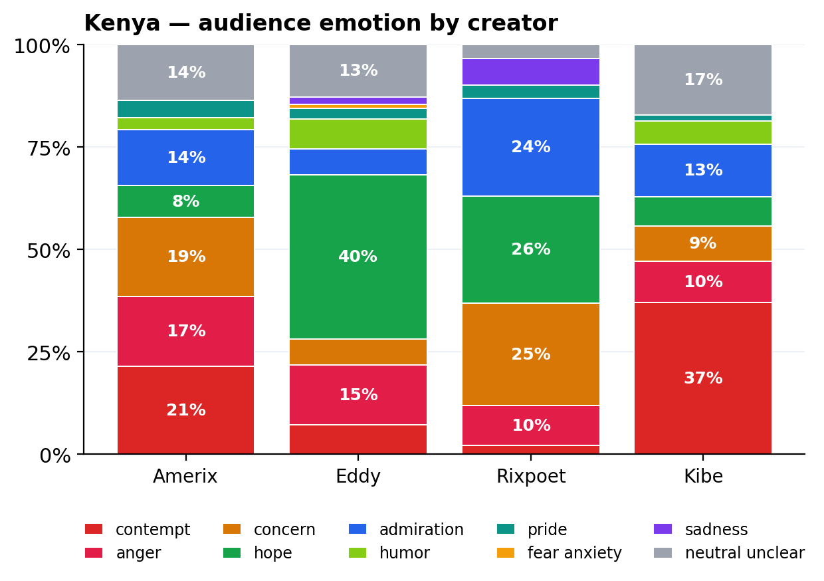 | 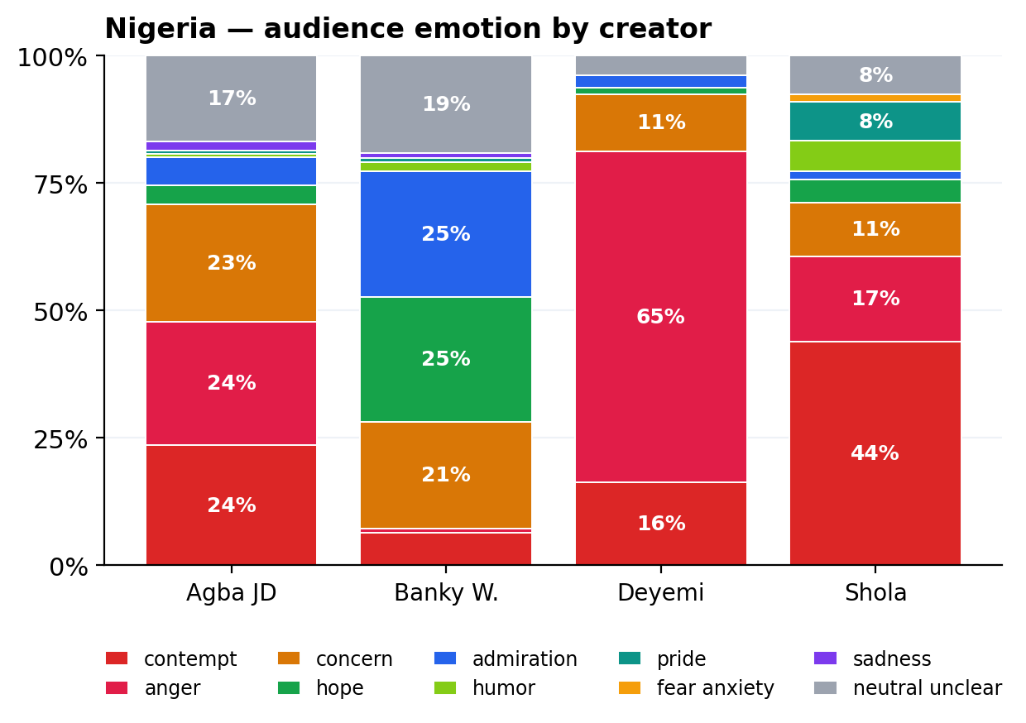
Kenya — Rixpoet's audience is dominated by hope + admiration + concern. | Nigeria — Deyemi's audience is anger-dominated; Banky Wellington's is hope + admiration.

18. Audience argument types
Kenya's audience leans on personal_experience (29%) — the testimony register driven by Rixpoet's mental-health content. Nigeria's audience leans on generalisation (40%) — broad claims about “women”, “men”, “society”, consistent with the dating / relationship topic mix.
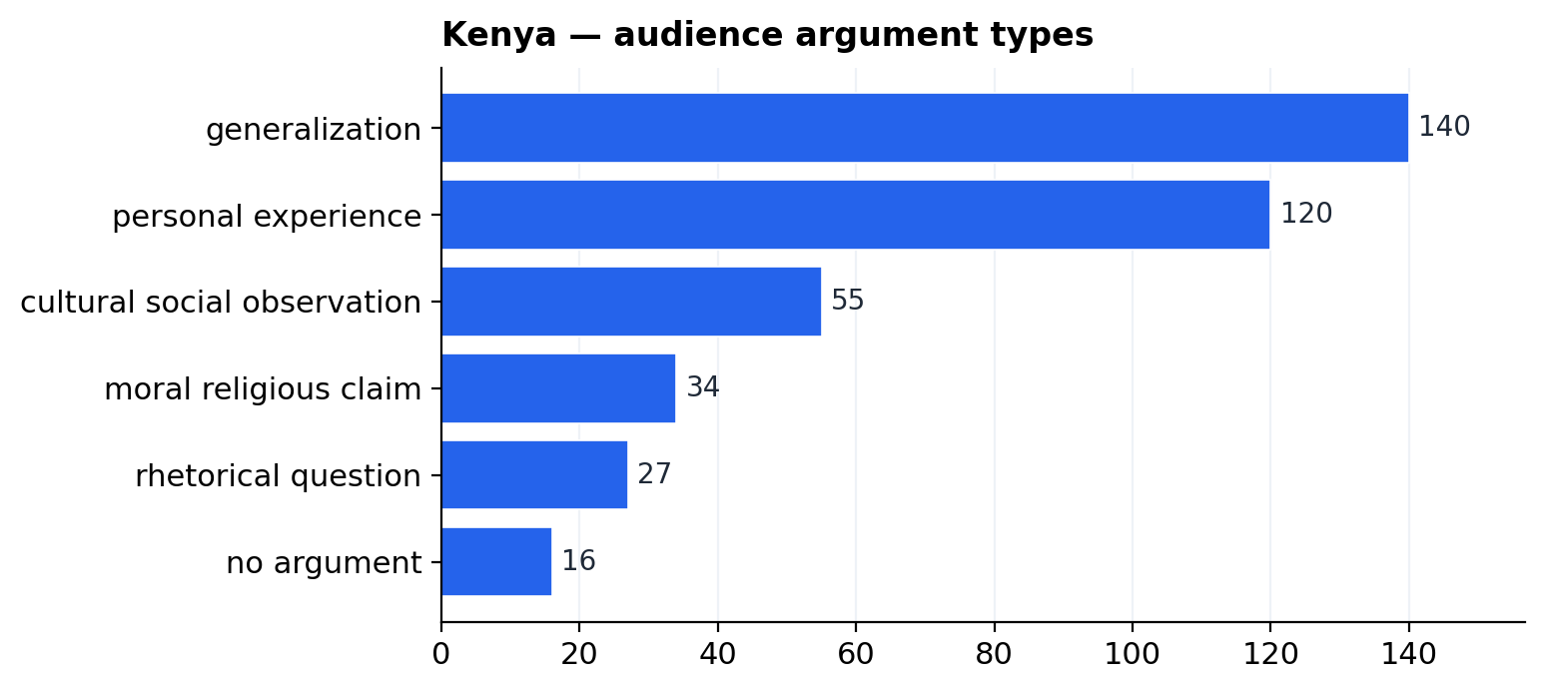 | 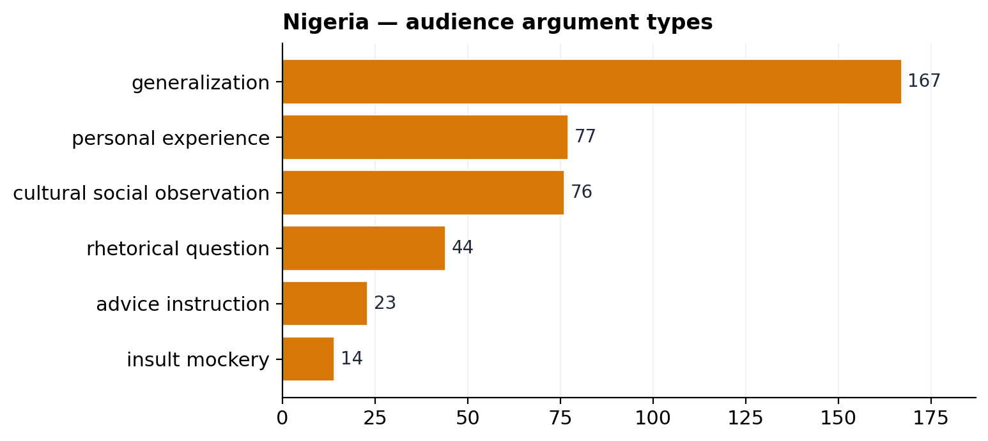
Kenya — generalization (140) leads, personal_experience (120) close behind. | Nigeria — generalization dominates (167); personal_experience (77) is half Kenya's rate.

19. Audience-side misogyny / sexism
Audiences both reproduce and challenge sexism in the original posts. Hostile sexism in audience comments concentrates under the regressive creators that already produce it.
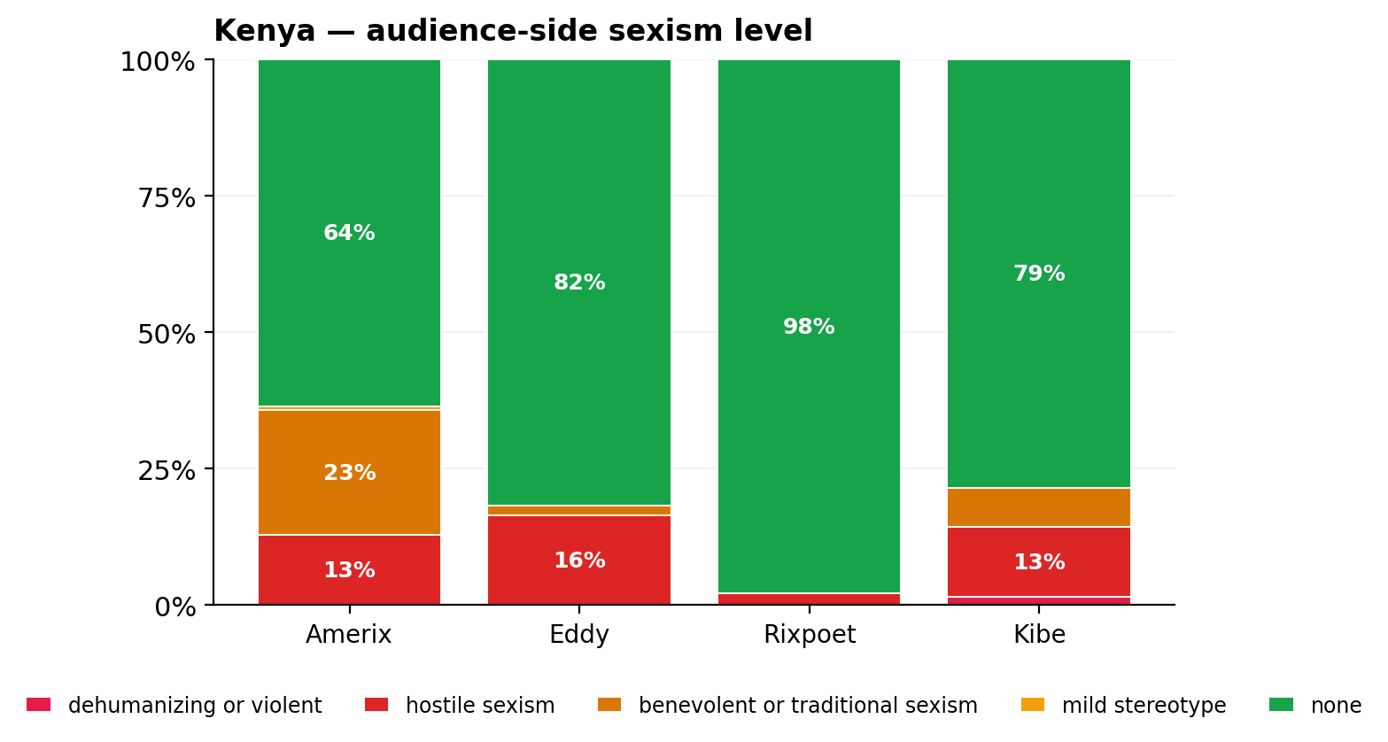 | 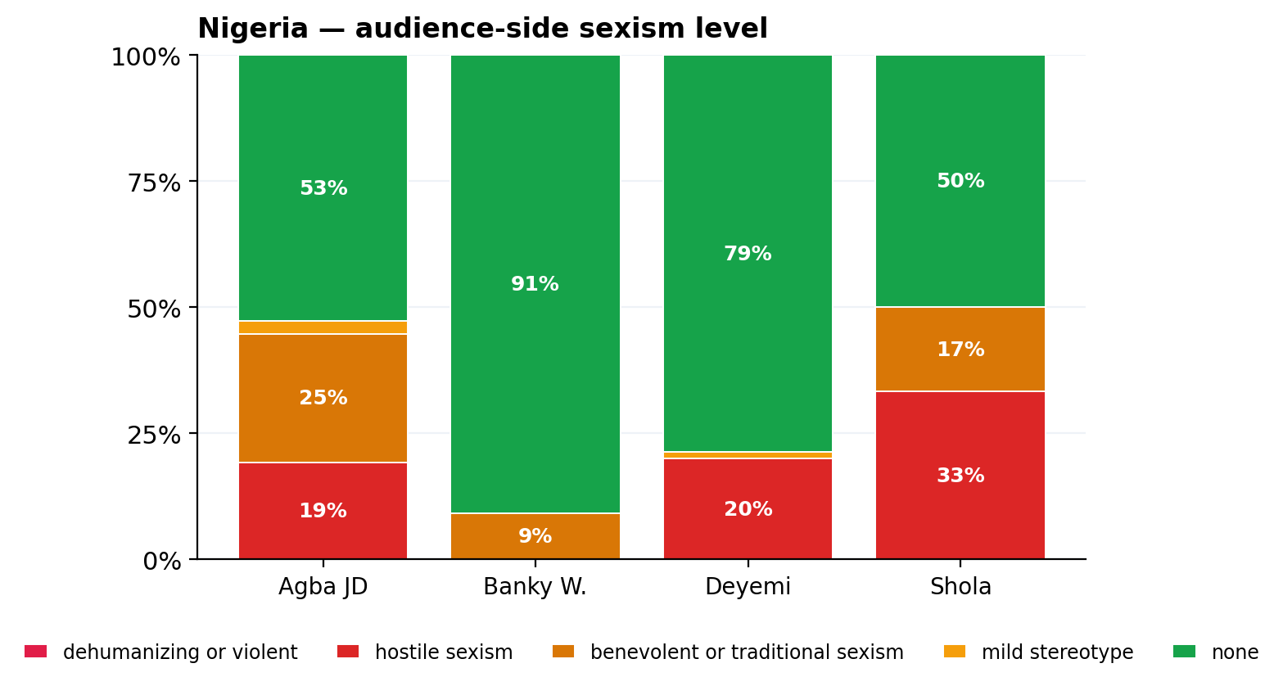
Kenya — Amerix's audience reproduces hostile sexism; Rixpoet's audience codes 0%. | Nigeria — Agba JD and Shola audiences carry hostile sexism; Banky audience codes 0%.

PART E · LINKED CONTENT – AUDIENCE INSIGHTS
20. Frame gap — where audiences open or close frames
The frame comparison in Section 5 shows where audiences are not just reflecting creators but opening or closing frames. Two specific patterns are large enough to flag for the playbook:
• Audiences inflate traditional_gender_order (KE 79→58, NG 61→111) and female_blame (KE 36→48, NG 75→82). The audience does the regressive frame-keeping work even when the content does not foreground it most.
• Nigerian audiences open violence_safety 39 times under content that codes the frame only 3 times — an unmet demand for GBV / safety conversation that creators do not currently lead.
• Trauma_healing is concentrated and reciprocal in Kenya (con 59 / aud 62, almost entirely Rixpoet + Eddy). The frame does not exist in the Nigerian set (con 5 / aud 1). This is a counternarrative gap, not a saturation.
21. Where audiences amplify regressive frames
By creator, the difference between intensifies-original-message and challenges-original-message tells us where the audience is doing the amplification work and where it is doing the resistance work.
Creator | Country | Intensifies | Extends | Challenges | Comments (n)
Amerix | Kenya | 53 (38%) | 4 (3%) | 76 (54%) | 140
Eddy | Kenya | 49 (45%) | 42 (38%) | 13 (12%) | 110
Rixpoet | Kenya | 32 (35%) | 46 (50%) | 6 (7%) | 92
Kibe | Kenya | 29 (41%) | 4 (6%) | 26 (37%) | 70
Agba JD | Nigeria | 68 (42%) | 8 (5%) | 61 (38%) | 161
Banky W. | Nigeria | 39 (35%) | 41 (37%) | 12 (11%) | 110
Deyemi | Nigeria | 37 (46%) | 2 (2%) | 38 (48%) | 80
Shola | Nigeria | 37 (56%) | 4 (6%) | 24 (36%) | 66

PART F · TOWARD THE PLAYBOOK (SCOPE COMPONENT 4 BRIDGE)
22. Counternarrative levers visible in the data
These are the narrative + rhetorical bundles that already produce healthier engagement signatures in this sample. Each is a candidate the playbook can lean on.
LEVER 1 — THE HEALING / TESTIMONY REGISTER
Pattern: personal_story + testimony rhetoric + trauma_healing frame + “men should be emotionally open” narrative.
Why: produces highest rates of audience personal_disclosure and learning_reflection in the dataset. Disarms male grievance without arguing against it.
Where it works now: Rixpoet (KE), Eddy Kimani (KE), Banky Wellington (NG).
Risk: thin Nigerian footprint — only Banky Wellington carries it. Playbook should multiply this register in Nigeria.

LEVER 2 — FATHERHOOD-LED EQUALITY
Pattern: commentary + advice rhetoric + fatherhood_responsibility frame + “men should be equal partners” narrative.
Why: positions equality not as concession but as the responsible-father identity. Audiences extend rather than intensify.
Where it works now: Banky Wellington, Philip Karanja, Deyemi Okanlawon (latter draws opposition — content needs to be paired with healing register to land).

LEVER 3 — REFRAME THE PROVIDER STORY WITHOUT ABANDONING IT
The dominant Nigerian regressive narrative is “men should provide and succeed”. Direct attack will not work; the provider-pressure frame is real for adolescent boys and young men. Counternarrative opportunity: decouple provider success from women's submission. Banky Wellington's content already does this; the playbook can scale that move.

LEVER 4 — MEET THE UNMET DEMAND FOR GBV / SAFETY CONVERSATION
In Nigeria, violence_safety appears in 39 audience comments but only 2 content snippets. Audiences are asking for this conversation; creators are not leading it. The playbook can occupy this gap directly via Male Changemakers and progressive creators.

PART G · APPENDICES
23. Cross-country headline comparison
Metric | Kenya | Nigeria
Audience comments coded | 412 | 417
Content snippets coded | 394 | 381
Regressive content share | 43% | 43%
Progressive content share | 35% | 31%
Audience supports rate | 58% | 49%
Audience opposes rate | 37% | 44%
Hostile-sexism content rate | 21% | 20%
Mental-health topic share | 29% | 4%
Dating/relationships topic share | 16% | 37%
Top masculinity narrative | men are disadvantaged victims (92) | men should provide succeed (79)
Top rhetorical strategy | commentary opinion (179) | commentary opinion (237)
Top audience emotion | hope (84) | anger (103)
Top audience perceived impact | validation (155) | resistance pushback (150)
Top audience uptake mode | intensifies original message (163) | intensifies original message (181)
24. Methodology
Coding pipeline
Every row was coded by gpt-4o-mini with OpenAI Structured Outputs — a strict JSON schema enumerates every allowed value. Temperature is 0; responses are cached on disk by SHA-256 of (model, schema, system, user) so reruns are free. Per-row uncertainty is captured by a confidence column (high / medium / low) and a verbatim evidence_quote .
The sentiment enum is 4-valued (positive · negative · neutral · unclear). The LLM is the final coder.
Coding completeness
Layer | Kenya audience | Kenya content | Nigeria audience | Nigeria content
confidence = high | 321 (78%) | 365 (93%) | 335 (80%) | 340 (89%)
confidence = medium | 88 (21%) | 27 (7%) | 82 (20%) | 41 (11%)
confidence = low | 3 | 2 | 0 | 0
coding errors / fallbacks | 0 | 0 | 0 | 0
25. Limitations and validation
Not representative. Per Scope, the sample is a high-signal selection (3-5 creators per country). Findings should be read at the creator / post / archetype level, not generalised to “Kenyan men” or “Nigerian men”.
Sarcasm, slang, and code-switching (English / Sheng / Swahili / Pidgin) carry confidence = low; flagged in the methodology table above.

26. Representative quotes
Content side — Kenya
regressive · social accountability · Eric Amunga (Amerix)
“This woman had been assaulted by her husband after an evening quarrel because of food.”
regressive · female blame · Eric Amunga (Amerix)
“Women are performers, and you, the man, are the audience.”
progressive · trauma healing · Onyango Otieno (Rixpoet)
“the world out there people are struggling the same way we are struggling.”
progressive · male victimhood · Onyango Otieno (Rixpoet)
“these are symptoms of trauma that you you are exhibiting in your behavior”
regressive · self improvement · Eddy Kimani
“Because I'm the man. That was my thinking at the time.”
regressive · male victimhood · Andrew Kibe
“your biggest bully was your mother.”
Content side — Nigeria
regressive · trauma healing · Banky Wellington
“I would never allow a woman... to put me in that position again.”
progressive · fatherhood responsibility · Banky Wellington
“fathers are supposed to give love and discipline, right?”
mixed · mixed unclear · Ebuka Obi-Uchendu
“the general perception, and I use general very strongly, is that Nigerian men are not that way.”
progressive · traditional gender order · Ebuka Obi-Uchendu
“45% of men today aged 18 to 26 report that they've never approached a woman in person for dating.”
regressive · female blame · Wizarab
“You are hoping he leaves his girlfriend for you one day. Keep dreaming”
progressive · equality partnership · Wizarab
“Tell her you're are shy and smile.”
Audience side — Kenya
opposes · female blame · Eddy Kimani
“this empowerment of women, has challenged the men, and men have nothing left to challenge women with”
supports · trauma healing · Onyango Otieno (Rixpoet)
“I try everyday to think positive about myself and after I get some money am planning to at least try counseling.”
supports · trauma healing · Onyango Otieno (Rixpoet)
“I have been on the healing path for 15 years now and am glad am free!!”
supports · self improvement · Eddy Kimani
“peace is priceless to me now.”
supports · self improvement · Eric Amunga (Amerix)
“A man's desire for greatness is so strong that he will attempt to experience it through someone else.”
supports · provider pressure · Andrew Kibe
“If you love cars, you don’t park one in the garage for life and act like the showroom doesn’t exist.”
Audience side — Nigeria
supports · self improvement · Banky Wellington
“the shame didn't just come from outside. They were already ashamed inside.”
supports · traditional gender order · Banky Wellington
“Loving Banky's push back on many aspects of this conversation that was sliding into lazy generalizing mindsets.”
opposes · violence safety · Deyemi Okanlawon
“You can't talk about rapists without talking about the accusers.”
opposes · male victimhood · Deyemi Okanlawon
“you hopeless, horny degenerates calling yourselves men are the reason innocent boys have no say”
opposes · female blame · Shola
“They are never, ever satisfied even when given everything”
opposes · female blame · Shola
“women are then perceived to age faster, they often become desperate for marriage”

Generated from outputs_llm_eda/ (Kenya) and outputs_llm_eda_nigeria/ (Nigeria) coded CSVs. Coder: gpt-4o-mini, schema v2 (sentiment 4-valued). All section numbers map to the Gates Masculinity Project Scope of Work.

